Monument Square District
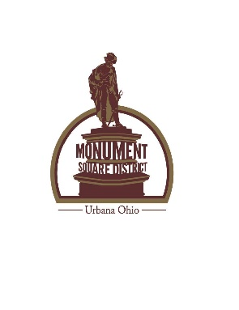
PARTNERSHIP AGREEMENT
All requests must be received by Monument Square District no later than 15 days prior to the event.
DETAILS OF EVENT
Event Name: __________________________________________________________
Event (start) Date: ___________________ Event (end) Date: __________________
Event (start) Time: ___________________ Event (end) Time: ___________________
SPECIAL INSTRUCTIONS: (Must be followed by all applicants)
____BANNER/SIGNAGE (if in the downtown/Heritage Overlay)
(specify size and location within Legacy Park)
- Placement of banners/signage are subject to space availability
- All banners/signage must be temporary in nature
- All banners/signage must be installed and removed by user
____PERMITS/LICENSES: (All expenses are the responsibility of the applicant)
- Temporary liquor permit (required if serving alcohol at event)
- Other licenses specified by city, county or state in regard to the event
- Organization’s certificate of insurance including liquor liability insurance
____PREMISES – User’s responsibilities
- Set-up and tear down of event
- Cleaning and waste/litter removal
- Maintained and returned in a clean condition upon expiration of event
- Is financially responsible for cost of damages to the premises (Legacy Park) above and beyond normal wear and tear
- Will not conduct any hazardous or illegal activity
____OTHER (Brief description of event including purpose, non-profit status if applicable, private or public affair etc.)
_____________________________________________________________________________
_____________________________________________________________________________
_____________________________________________________________________________
BY SIGNING BELOW, THE APPLICANT AGREES TO HOLD THE MONUMENT SQUARE DISTRICT HARMLESS FROM ANY AND ALL RISKS, LIABILITY COSTS, CLAIMS OR CAUSES OF ACTION THAT MAY ARISE FROM SAID EVENT. SUCH ASSUMPTION OF RISK AND HOLD HARMLESS IS A MATERIAL CONDITION OF THE USE OF THE PUBLIC PROPERTY.
Applicant’s Signature ______________________________________ Date:__________________
PLEASE PRINT APPLICANT NAME HERE: _______________________________________________
Contact Phone: (possible additional questions):_________________________________________
++++++++++++++++++++++++++++++++++++++++++++++++++++++++++++++++++++++++++++++++++++++
APPROVED: ______________ DENIED: __________________ Date __________________________
Denied Reason: ___________________________________________________________
Monument Square District Representavtive:_____________________________________
* Completed request form can be mailed to Monument Square District, P. O. Box 707, Urbana,OH 43078 or email to MSDurbana@gmail.com
Signed form will be mailed to the address on Partnership Agreement

